Cairo University

Faculty of Engineering

Computer Engineering Department

ELC3252 Project

Group No. 8

Asmaa Mohamed Sec: 1 ID: 9220154

Rawan Ahmed Sec: 1 ID: 9220302

Somaya Saad Sec: 1 ID: 9202666

Shehab Khaled Sec: 1 ID: 9220393

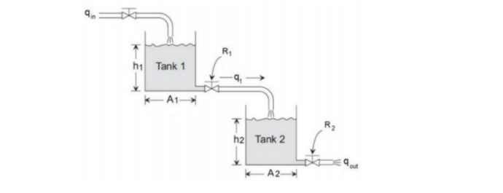

1. Transfer Functions (Hand analysis):

A₁ = 5, A₂ = 4, R₁ = 3, R₂ = 5

## Equations:

$q_{\text{in}}-q_{1}=A_{1}\frac{dh_{1}}{dt}$ → Qin - Q₁ = A₁ s H₁

$q_{1}-q_{o}=A_{2}\frac{dh_{2}}{dt}$ → Q₁ - Q₀ = A₂ s H₂

$\frac{h_{1}\left(t\right)-h_{2}\left(t\right)}{R_{1}}=q_{1}\left(t\right)$ → H₁ - H₂ = R₁ Q₁

$\frac{h_{2}\left(t\right)}{R_{1}}=q_{o}\left(t\right)$ → H₂ = R₂ Q₀

$$Q_{1}=Q_{0}+A_{2}sH_{2}=Q_{0}+A_{2}sR_{2}Q_{0}$$

$$Q_{1}=Q_{0}\left(1+A_{2}R_{2}s\right)$$

$$H_{1}=H_{2}+R_{1}Q_{1}=R_{2}Q_{0}+R_{1}Q_{0}\left(1+A_{2}R_{2}s\right) \\ H_{1}=Q_{0}\left[R_{2}+R_{1}+R_{1}A_{2}R_{2}s\right]$$

$$Q_{in}=Q_{1}+A_{1}sH_{1}=Q_{0}\left(1+A_{2}R_{2}s\right)+A_{1}sQ_{0}\left[R_{2}+R_{1}+R_{1}A_{2}R_{2}s\right] \\ Q_{in}=Q_{0}\left[1+A_{2}R_{2}s+A_{1}R_{2}s+A_{1}R_{1}s+A_{1}A_{2}R_{1}R_{2}s^{2}\right]$$

$$Characteristic equation: 300s^{2}+60 s +1=0$$

**b) Transfer Functions:**

$$\frac{Q_{\text{o}}}{Q_{in}}=\frac{1}{A_{1}A_{2}R_{1}R_{2}s^{2} + {(A}_{2}R_{2}+A_{1}R_{2}+A_{1}R_{1})s + 1}=\frac{1}{300s^{2}+60s+1}$$

$$\frac{H_{1}}{Q_{in}}=\frac{R_{1}R_{2}A_{2}s+R_{1}+R_{2}}{A_{1}A_{2}R_{1}R_{2}s^{2} + {(A}_{2}R_{2}+A_{1}R_{2}+A_{1}R_{1})s + 1}=\frac{60s+8}{300s^{2}+60s+1}$$

$$\frac{Q_{1}}{Q_{\text{in}}}=\frac{A_{2}R_{2}s+1}{A_{1}A_{2}R_{1}R_{2}s^{2} + {(A}_{2}R_{2}+A_{1}R_{2}+A_{1}R_{1})s + 1}=\frac{20s+1}{300s^{2}+60s+1}$$

$$\frac{H_{2}}{Q_{\text{in}}}=\frac{R_{2}}{A_{1}A_{2}R_{1}R_{2}s^{2} + {(A}_{2}R_{2}+A_{1}R_{2}+A_{1}R_{1})s + 1}=\frac{5}{300s^{2}+60s+1}$$

1. Transfer functions (MATLAB):

1. System stability:

* **Hand Analysis:** Check poles’ locations of the c/c eqn.
$$c/c eqn.=300s^{2}+60s+1$$

$$p_{1},p_{2}=\frac{-b±\sqrt{b^{2}-4ac}}{2a}=\frac{-60±\sqrt{{60}^{2}-4 × 300}}{2 × 300}$$

$$p_{1}=-0.1816, p_{2}=-0.01835$$

* **Verification with MATLAB:**

* **Conclusion:** poles are in the LHP → System is stable.

1. Step responses:

**Notice how the system is over damped:**

$$s² + 2 ζ ωₙ s + ωₙ² = 0 → s² + \frac{60}{300} s + \frac{1}{300} = 0$$

$$ωₙ² = \frac{1}{300}$$

$$2 ζ ωₙ = \frac{60}{300}$$

$ζ=\sqrt{3}≈1.73>1$ → overdamped system.

1. Tracking input Hd:

1. H1 & H2 for Hd = 5m:

where

For kp = 1 →

1. H2 response calculations:

* Natural frequency: $⍵_{n}=\sqrt{0.02}$
* Damping ratio: $z=\frac{0.2}{2\sqrt{0.02}}=\frac{\sqrt{2}}{2}$

$0 < z < 1$ → Under damped

$$⍵_{d}=⍵_{n}\sqrt{1-z^{2}} = 0.1$$

* Peak time: $t_{p}=\frac{π}{⍵_{d}} = 10π = 31.4$
* Relative overshoot: $M_{p}=e^{\frac{-zπ}{\sqrt{1-z^{2}}}}=0.043$
* Rise time: $t_{r}=\frac{π-cos^{-}1\left(z\right)}{⍵_{d}}=\frac{15}{2}π=23.56$
* Settle time: $t_{s}=\frac{4}{z⍵_{n}}=40$
* Steady state error: type_0 system, step input:

$$k_{p}=\lim_{s→0}{GH = \lim_{s→0}{ \frac{5}{300s^{2}+60s+1} = 5 } }$$

$$ess=\frac{M}{1+k_{p}}=\frac{5}{1+5}=0.833$$

1. Effect of Kp on tracking hHHd:
2. **For kp = 1:**

$$c/c eqn.=300s^{2}+60s+6=s^{2}+\frac{60}{300}s+\frac{6}{300}=s^{2}+0.2s+0.02=0$$

* Natural frequency: $⍵_{n}=\sqrt{0.02}$
* Damping ratio: $z=\frac{0.2}{2\sqrt{0.02}}=\frac{\sqrt{2}}{2}$

$0 < z < 1$ → Under damped

$$⍵_{d}=⍵_{n}\sqrt{1-z^{2}} = 0.1$$

* Peak time: $t_{p}=\frac{π}{⍵_{d}} = 10π = 31.4$
* Relative overshoot: $M_{p}=e^{\frac{-zπ}{\sqrt{1-z^{2}}}}=0.043$
* Rise time: $t_{r}=\frac{π-cos^{-}1\left(z\right)}{⍵_{d}}=\frac{15}{2}π=23.56$
* Settle time: $t_{s}=\frac{4}{z⍵_{n}}=40$
* Steady state error: $$ess=\frac{5}{1+5}=0.833$$

1. **For kp = 10:**

$$c/c eqn.=300s^{2}+60s+51=s^{2}+\frac{60}{300}s+\frac{51}{300}=s^{2}+0.2s+0.17=0$$

* Natural frequency: $⍵_{n}=\sqrt{0.17}$
* Damping ratio: $z=\frac{0.2}{2\sqrt{0.17}}=\frac{\sqrt{17}}{17}$ = 0.243

$0 < z < 1$ → Under damped

$$⍵_{d}=⍵_{n}\sqrt{1-z^{2}} = \frac{2}{5}=0.4$$

* Peak time: $t_{p}=\frac{π}{⍵_{d}} = \frac{5}{2}π = 7.854$
* Relative overshoot: $M_{p}=e^{\frac{-zπ}{\sqrt{1-z^{2}}}}=0.4559$
* Rise time: $t_{r}=\frac{π-cos^{-}1\left(z\right)}{⍵_{d}}=4.539$
* Settle time: $t_{s}=\frac{4}{z⍵_{n}}=40$
* Steady state error: $$ess=\frac{5}{1+50}=0.098$$

1. **For kp = 100:**

$$c/c eqn.=300s^{2}+60s+501=s^{2}+\frac{60}{300}s+\frac{501}{300}=s^{2}+0.2s+1.67=0$$

* Natural frequency: $⍵_{n}=\sqrt{1.67}=1.2922$
* Damping ratio: $z=\frac{0.2}{2\sqrt{1.67}}=0.07738$

$0 < z < 1$ → Under damped

$$⍵_{d}=⍵_{n}\sqrt{1-z^{2}} = 1.288$$

* Peak time: $t_{p}=\frac{π}{⍵_{d}} = 2.4391$
* Relative overshoot: $M_{p}=e^{\frac{-zπ}{\sqrt{1-z^{2}}}}=0.7836$
* Rise time: $t_{r}=\frac{π-cos^{-}1\left(z\right)}{⍵_{d}}=1.2755$
* Settle time: $t_{s}=\frac{4}{z⍵_{n}}=40$
* Steady state error: $$ess=\frac{5}{1+500}=0.00998$$

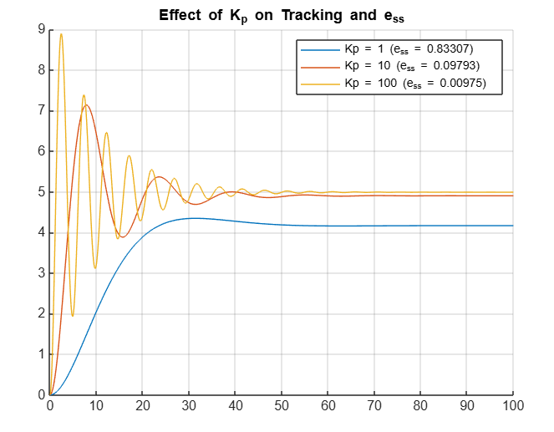

### Effect of Increasing Kp​ on System Performance:

* **Damping Ratio:**

The damping ratio decreases proportionally with $kp$.

$$z↓∝\frac{1}{\sqrt{kp}↑}$$

* Damped Natural Frequency **​:**

The damped natural frequency increases with higher $⍵_{d}↑$.

* Relative overshooting:

The relative overshoot increases due to the reduced damping ratio $M_{p}↑$.

* Peak time:

The peak time decreases because the system responds faster ${ t}_{p}↓$.

* Rising time:

The rise time decreases, reflecting quicker initial response ${ t}_{r}↓$.

* Steady state error:

The steady state error for a step input decreases with higher $kp$ *.*

* Settle time:

The settling time remains relatively unaffected by $kp$ .

While $⍵_{n}$ ​ increases, the reduction in $z$ counterbalances its effect, leaving $t_{s}$ ​ approximately constant.

1. P-Controller in Error Reduction:

$$H_{2}=6m$$

$$\frac{H_{2}}{H_{d}}=\frac{5k_{p}}{300s^{2}+60s+1+5k_{p}}$$

$$k_{p}=\lim_{s→0}{GH = \lim_{s→0}{\begin{aligned}\frac{5k_{p}}{300s^{2}+60s+1}=5K_{p} \\ \end{aligned}} }$$

$$ess=\frac{M}{1+k_{p}}=\frac{5}{1+5k_p}< 0.01$$

$$0.05k_{p}+0.01>5$$

$$k_{p}>99.8$$

$$H_{2_{\text{ss}}}{\left.​\right|}_{H_{d}=\frac{5}{s}} = \lim_{s→0}{sH_{2}}= \lim_{s→0}{s\frac{H_{2}}{H_{\text{d}}}H_{\text{d}} }$$

$$= \lim_{s→0}{s\frac{5k_{p}}{300s^{2}+60s+1+5k_{p}}\frac{5}{s}}$$

$$= \lim_{s→0}{\frac{25k_{p}}{300s^{2}+60s+1+5k_{p}}=}\frac{25k_{p}}{1+5k_{p}} = 4.99 < 6$$

### Can reach error < 0.01 with P-Controller only if kp > 99.8

1. Eliminate ess, H2 = 6:

* **Requirements:**

1. Eliminate ess → PI-Controller
2. Reduce Mp as tank’s height = 6 m → PD controller

$∴$ Use PID-controller

* **Error analysis:**

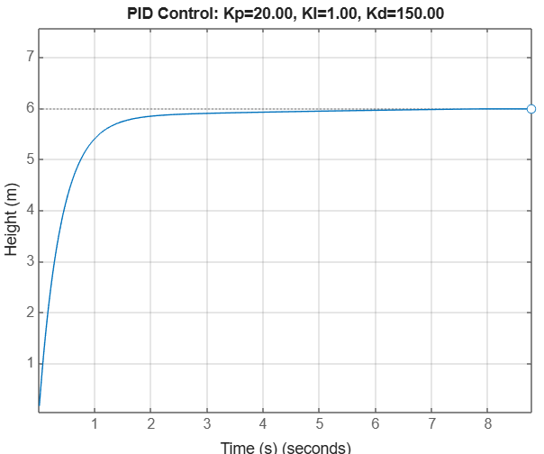

* **Check stability:**

$c/c eqn. =300s^{3}+810 s^{2}+101 s+5=0$

bc > ad → stable

error eliminated.

overshoot eliminated.